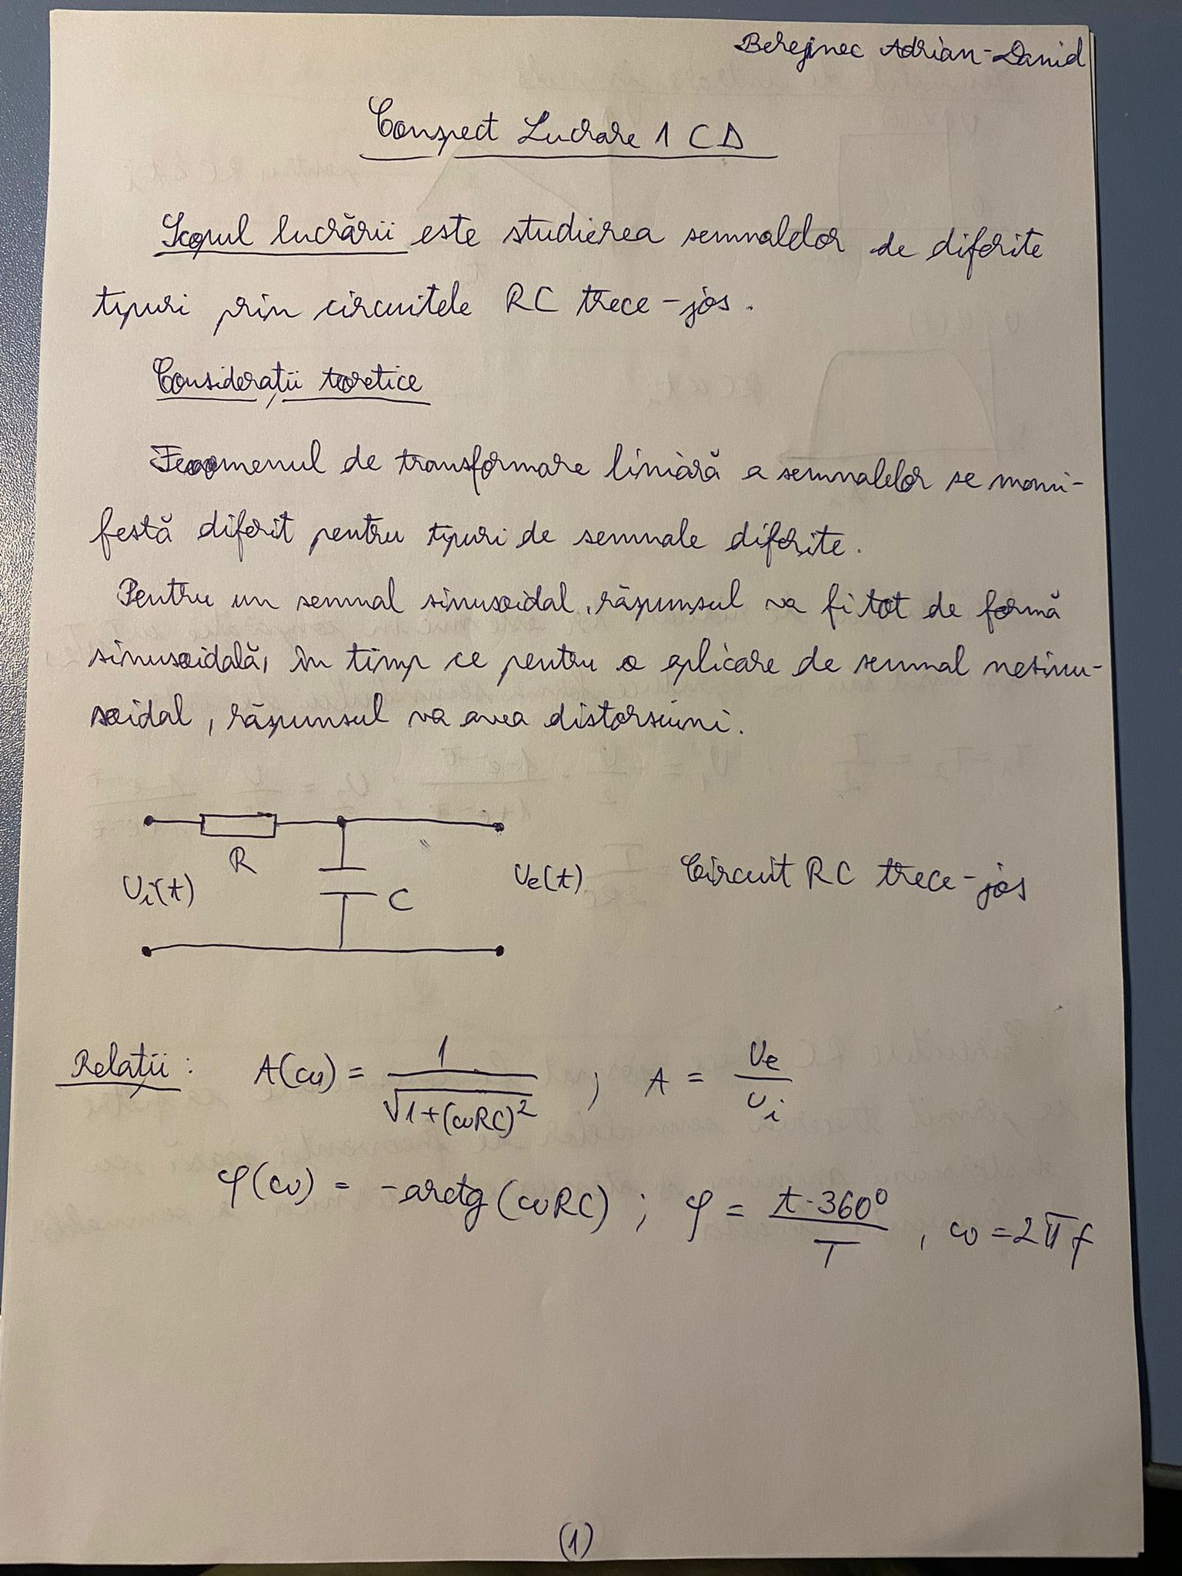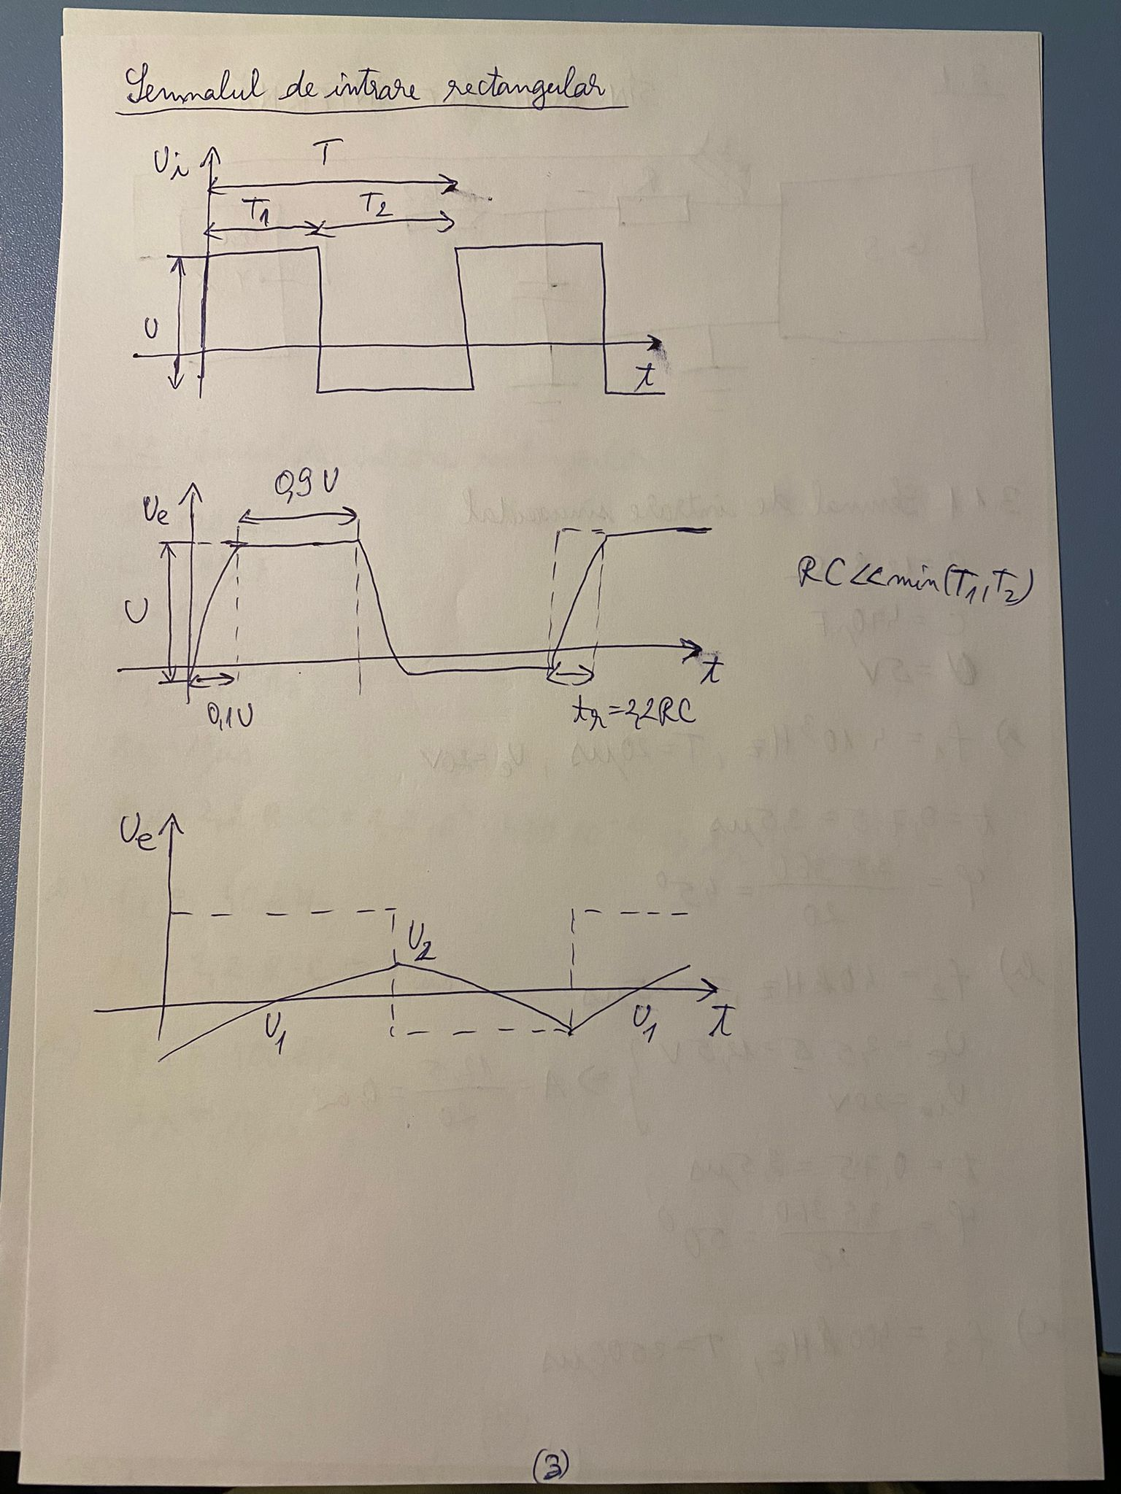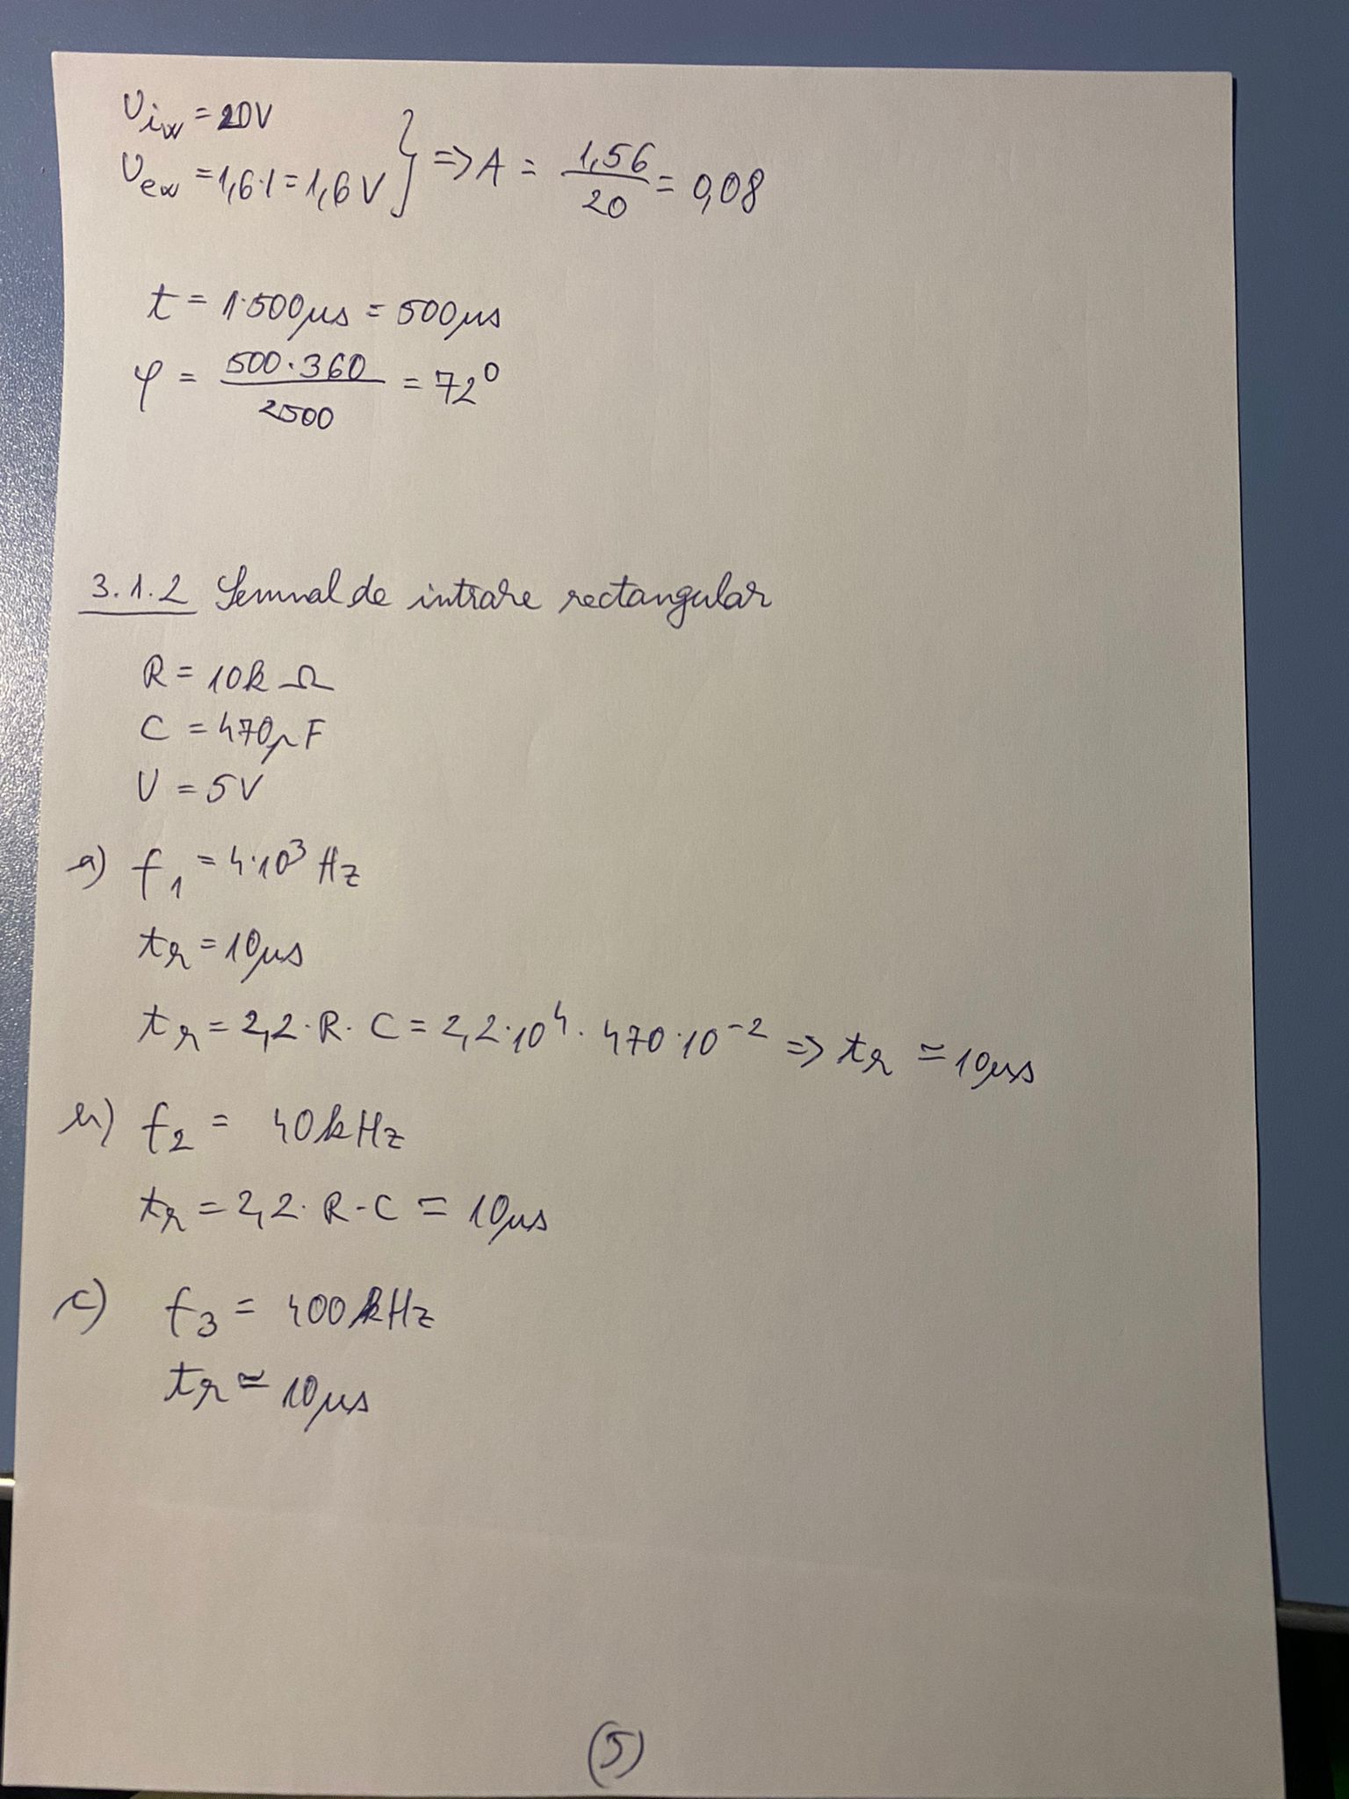

3.1.1

a) f1 = 4 kHz :

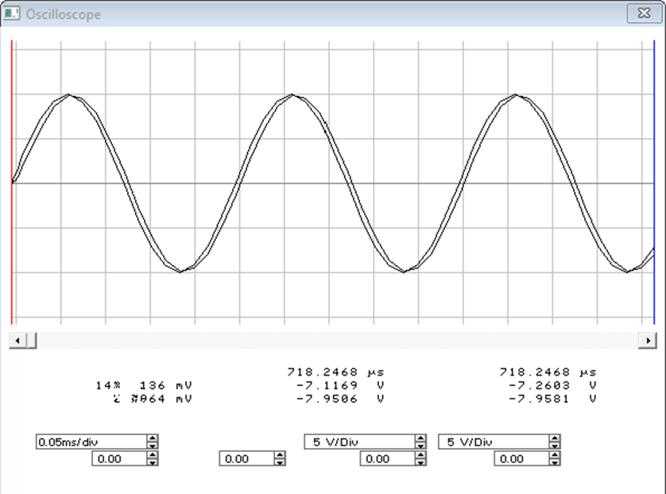

b) f2 = 40 kHz :

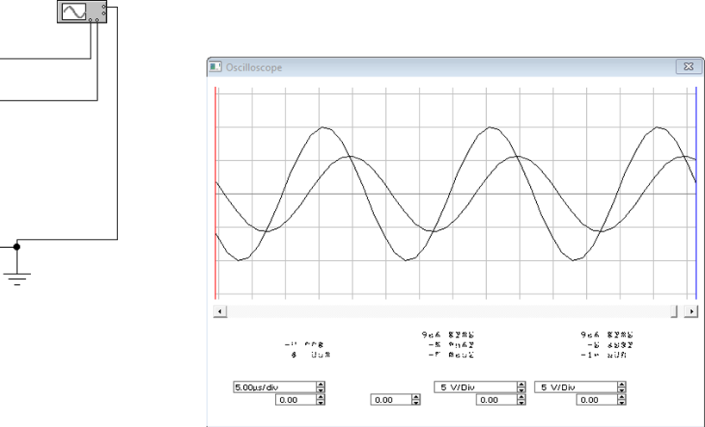

c) f3 = 400 kHz :

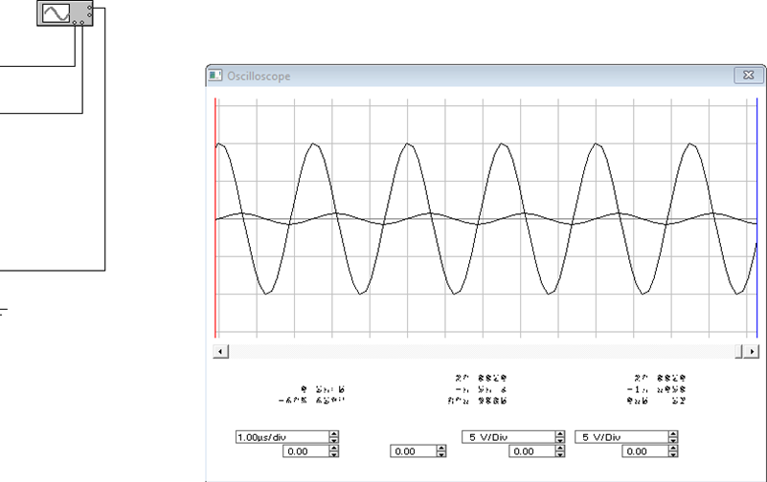

3.1.2

a) f1 = 4 kHz :

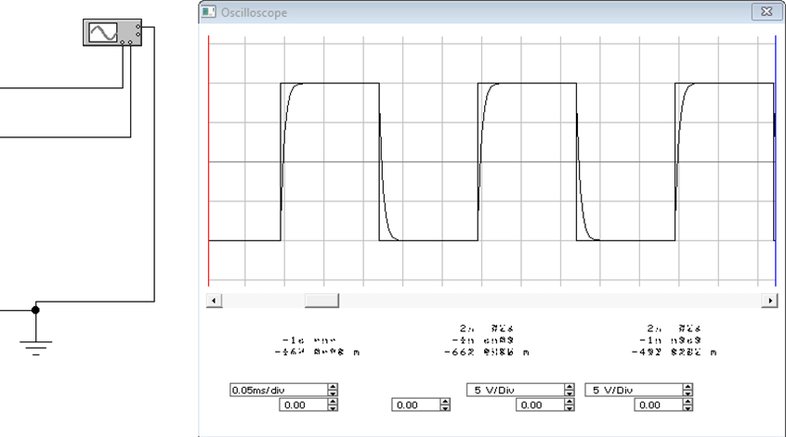

b) f2 = 40 kHz :

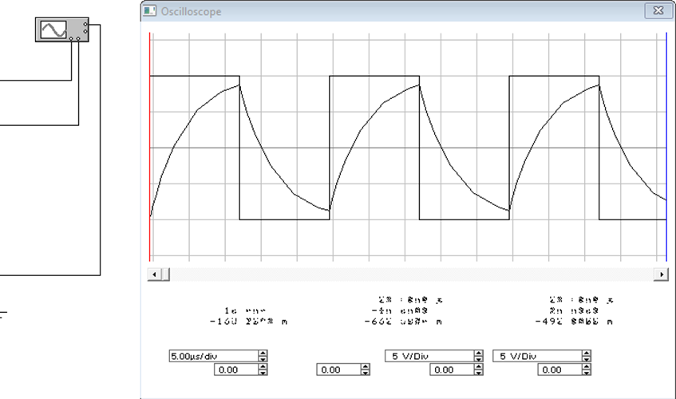

c) f3 = 400 kHz :

